**Batch: B-1 Roll No.: 1711074**

**Experiment / Assignment / Tutorial No. 8**

**Grade: AA / AB / BB / BC / CC / CD /DD**

**Signature of the Staff In-charge with date**

|  |
| --- |
| **Batch: B-1 Roll No.: 1711074 Experiment / Assignment / Tutorial No.: 8** |

|  |
| --- |
| **Title: Installation & configuration of FTP Server.** |

**Objective:**

1. To install & configure FTP server & handle remote operations.

**_____________________________________________________________________________**

**Expected Outcome of Experiment:**

CO3. Manage the configurations by using network administration tools.

**___________________________________________________________________________**

**Books/ Journals/ Websites referred:**

1. Linux Lab - Open source Technology: Ambavade –Dreamtech.
2. https://help.ubuntu.com/lts/serverguide/ftp.html
3. http://www.krizna.com/ubuntu/setup-ftp-server-on-ubuntu-14-04-vsftpd/
4. https://www.cyberciti.biz/faq/linux-unix-ftp-commands/

**____________________________________________________________________________**

**Pre Lab/ Prior Concepts:**

Basics of computer networks, open source technology.

______________________________________________________________________________

**New Concepts to be learned:**  Installation of ftp, configurations for ftp, vsftpd, SSHD.

______________________________________________________________________________

**Introduction:**

An FTP Server (which stands for File Transfer Protocol Server) is a software application which enables the transfer of files from one computer to another. FTP is a way to transfer files to any computer in the world that is connected to the internet.

FTP is a standard network protocol used for the transfer of files between a client and server on a computer network. FTP is a very well-established protocol, developed in the 1970s to allow two computers to transfer data over the internet. One computer acts as the server to store information and the other acts as the client to send or request files from the server. The FTP protocol typically uses port 21 as its main means of communication. An FTP server will listen for client connections on port 21.

**What Do FTP Servers Do?**

FTP servers, and the more secure SFTP Server software, perform 2 basic tasks: “Put” and “Get.” You can put files on the FTP Server or get files from the FTP Server. If security is not a concern, FTP Server software is an easy and inexpensive way to accomplish this.

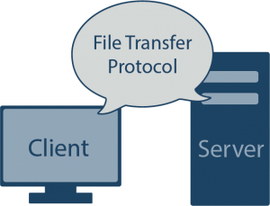

If you have remote employees who need to upload non-confidential information (such as timesheets, for example), or if you want to allow your customers to download white papers and documentation, an FTP Server works well for this purpose. If you are exchanging non-sensitive data with business partners, and the partner requires FTP or SFTP, you can quickly set up a server that will accept their data transfer. Some people even use FTP Servers for offsite backup so they can access their data should something physically happen to their files.

Further, backup applications will often write to an FTP or SFTP Server; for example, if you’re backing up your Cisco Unified Call Manager (CUCM), the data must be backed up to an SFTP Server like [Titan FTP Server](https://titanftp.com/?WhatisFTPServer).

**But Are FTP Servers Inherently Secure?**

Traditional FTP Servers do lack security- the only security feature that they really have is a login feature (username and password), which provides some degree of authentication and is a way to keep out unwanted users. However, secure FTP protocols do exist now to combat this issue. There are two main implementations of secure FTP: SFTP and FTP/S. These two secure file transfer protocols were designed to address the main weaknesses of FTP. For instance, both FTP/S and SFTP support encryption, which can keep a hacker from accessing data being transferred.

**Implementation details:**

**Installation of FTP:**

To installFTP server on Ubuntu 14.04(*vsftpd* ),need to run the following command:

**Step 1 »** Update repositories.

sudo apt-get update

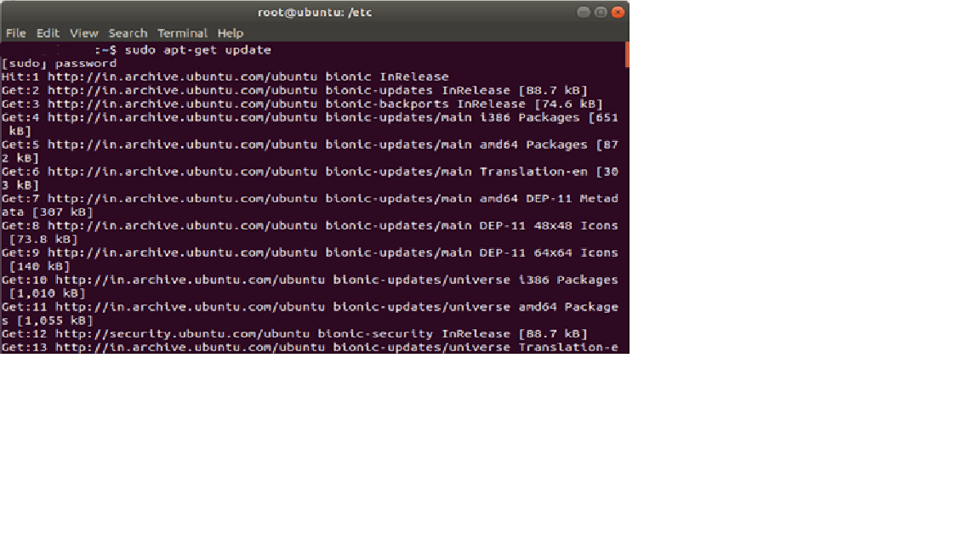

**Step 2 »** Install VsFTPD package using the below command.

sudo apt-get install vsftpd

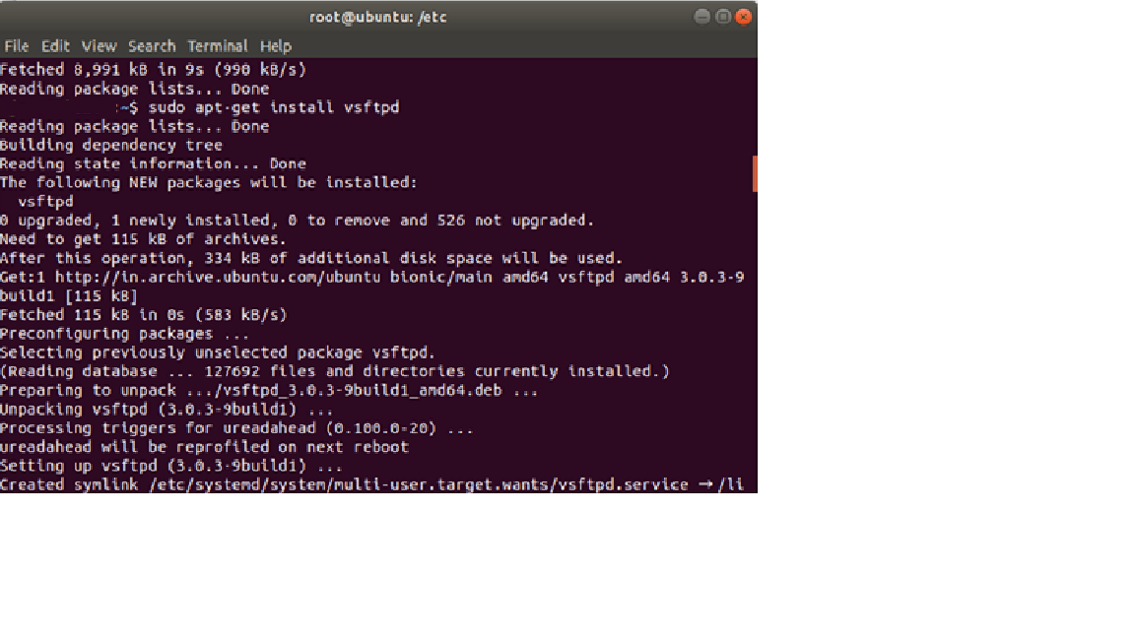

**Step 3 »** After installation open **/etc/vsftpd.conf** file and make changes as follows.  
 Uncomment the below lines (line no:29 and 33).

write_enable=YES  
local_umask=022» Uncomment the below line (line no: 120 ) to prevent access to the other folders outside the Home directory.  
chroot_local_user=YESand add the following line at the end.  
allow_writeable_chroot=YES» Add the following lines to enable passive mode.  
pasv_enable=Yes  
pasv_min_port=40000  
pasv_max_port=40100

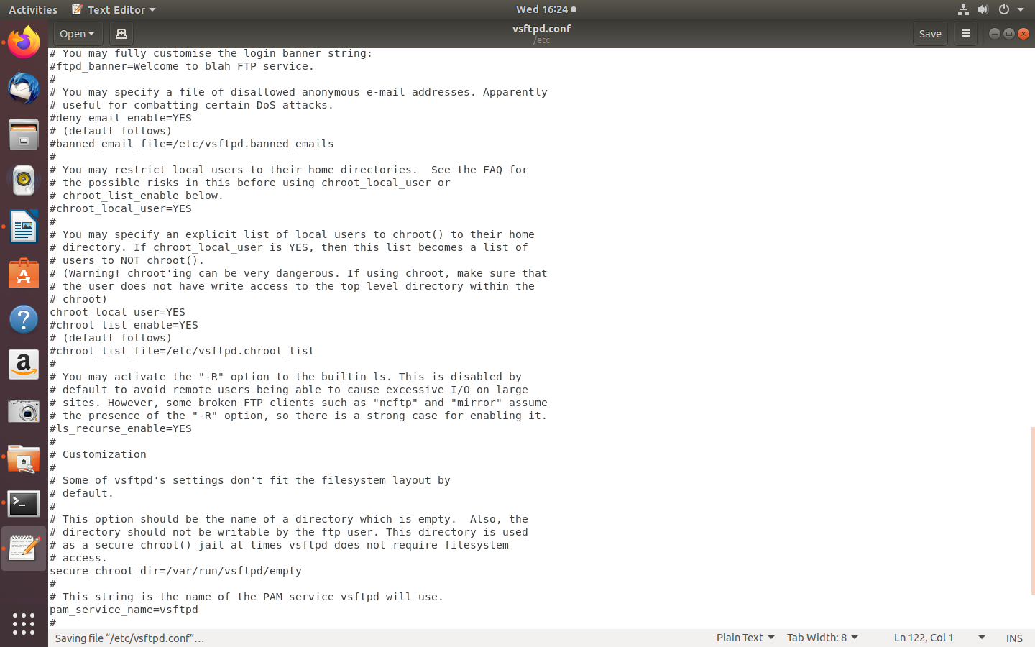

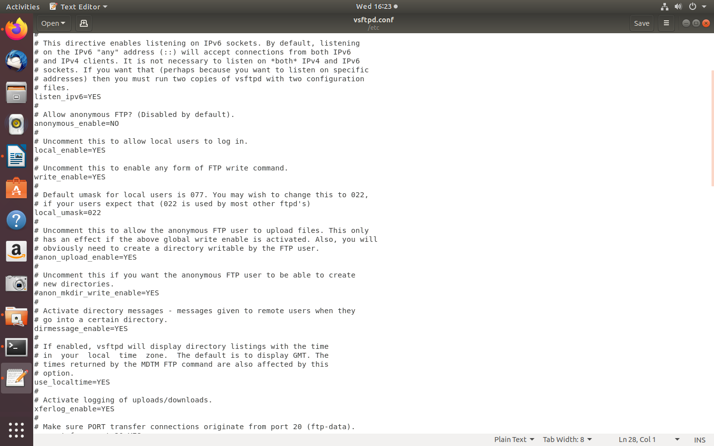

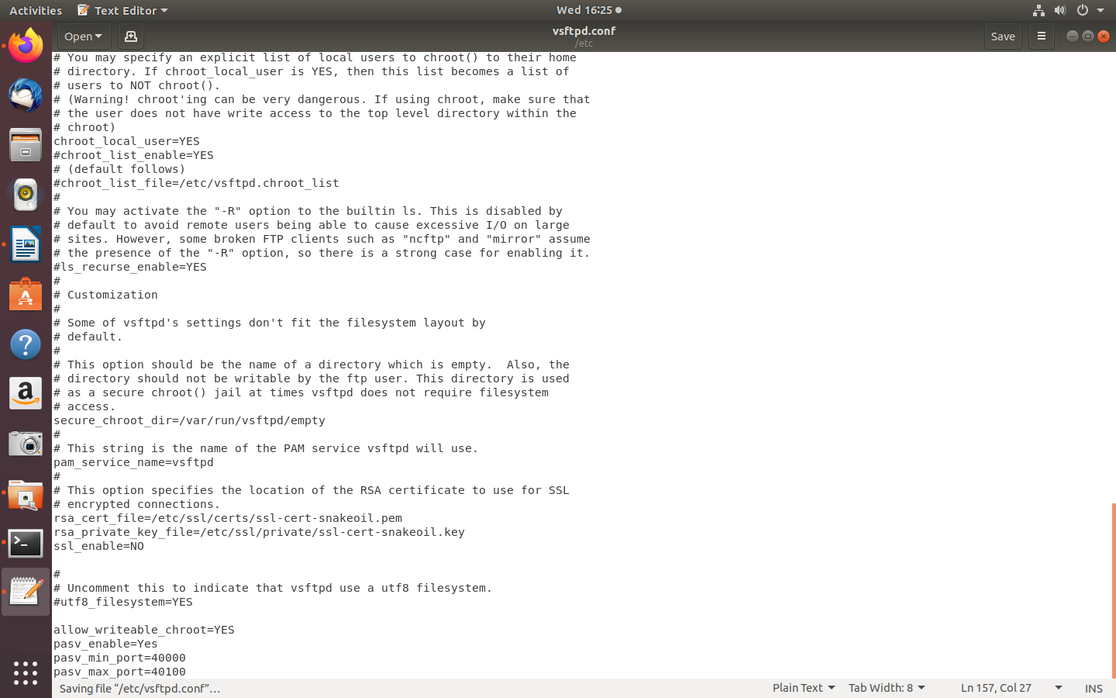

**Step 4 »**  Restart vsftpd service using the below command.

sudo service vsftpd restart

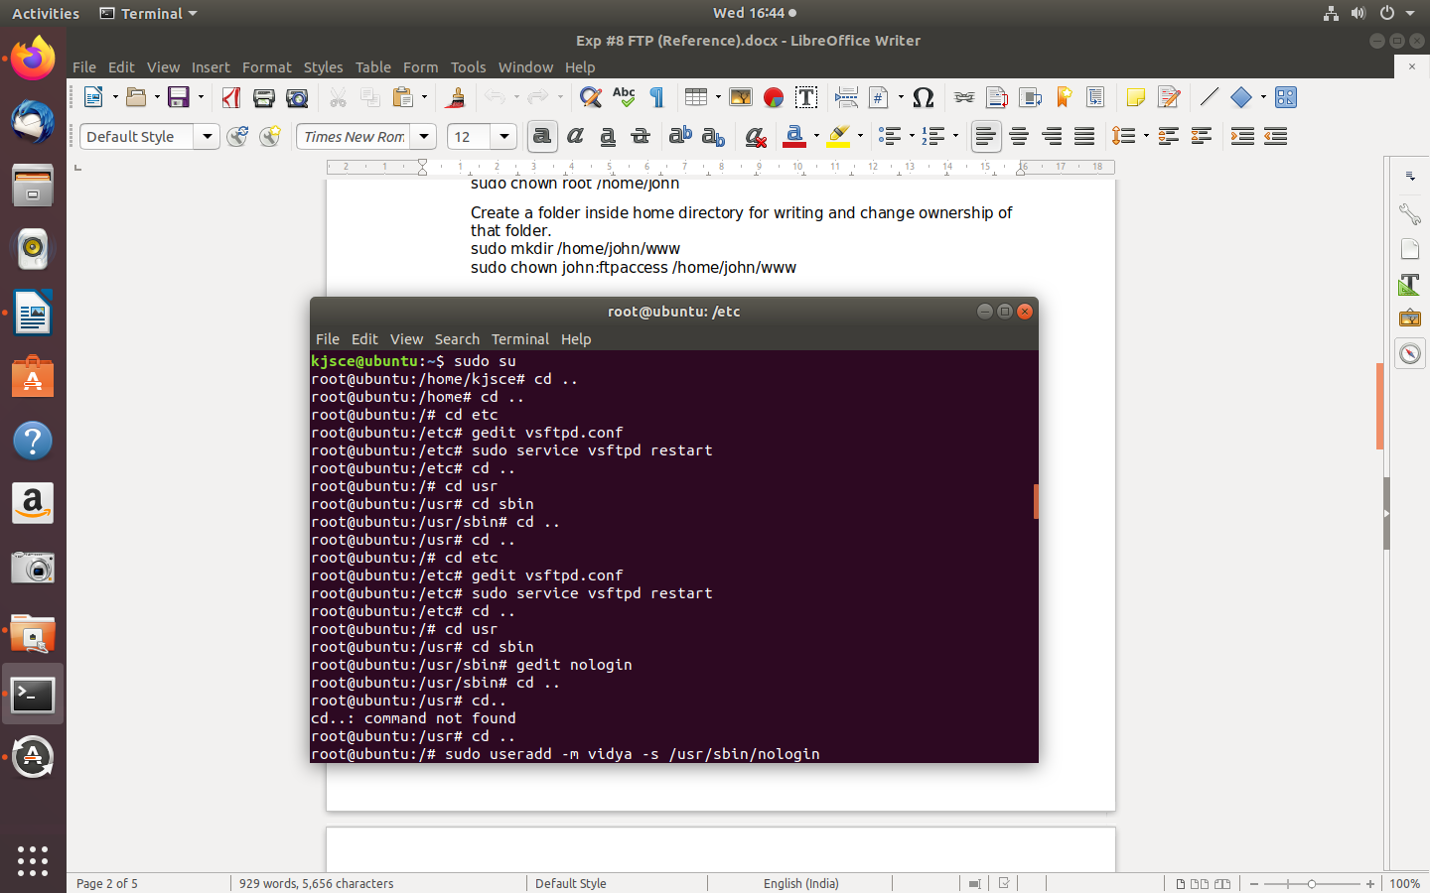

**Step 5 »**  Create user with the below command. Ftp server will listen on port 21.

Use shell to prevent access to the bash shell for the ftp users .

**/usr/sbin/nologin**

sudo useradd -m sayali -s /usr/sbin/nologin  
sudo passwd sayali

**Step 6 »** Allow login access for nologin shell .

Open **/etc/shells** and add the following line at the end.  
 /usr/sbin/nologin  
SFTP is called as “Secure FTP” which generally use SSH File Transfer Protocol . so we need openssh-server package installed , Issue the below command if it’s not already installed.

sudo apt-get install openssh-server

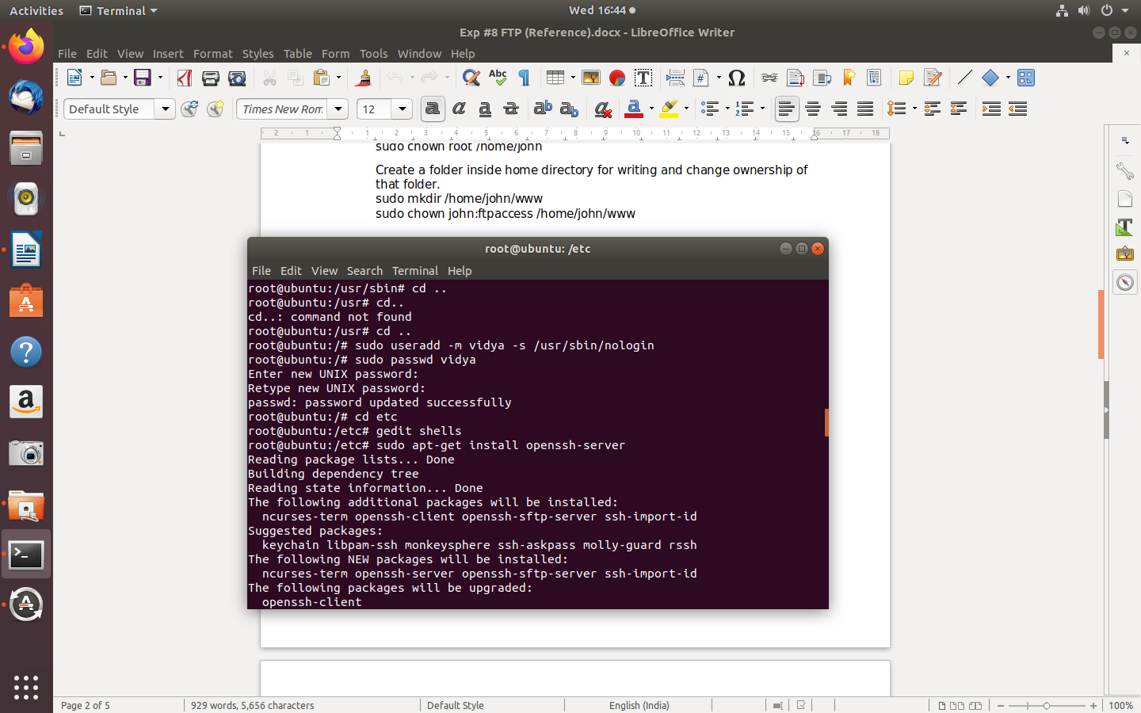

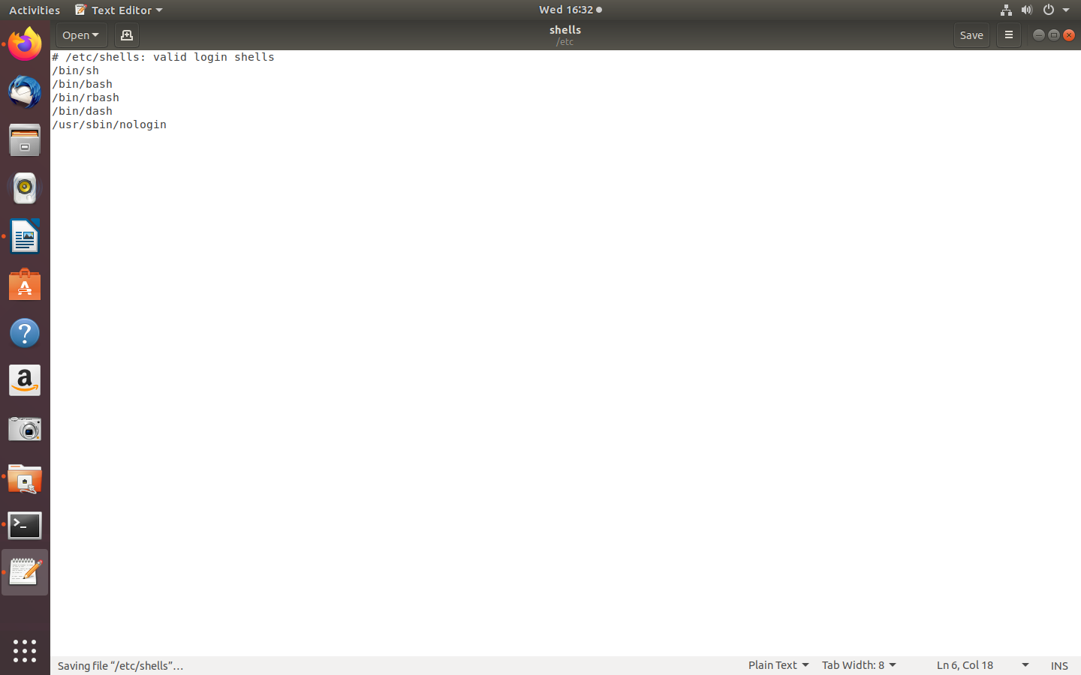

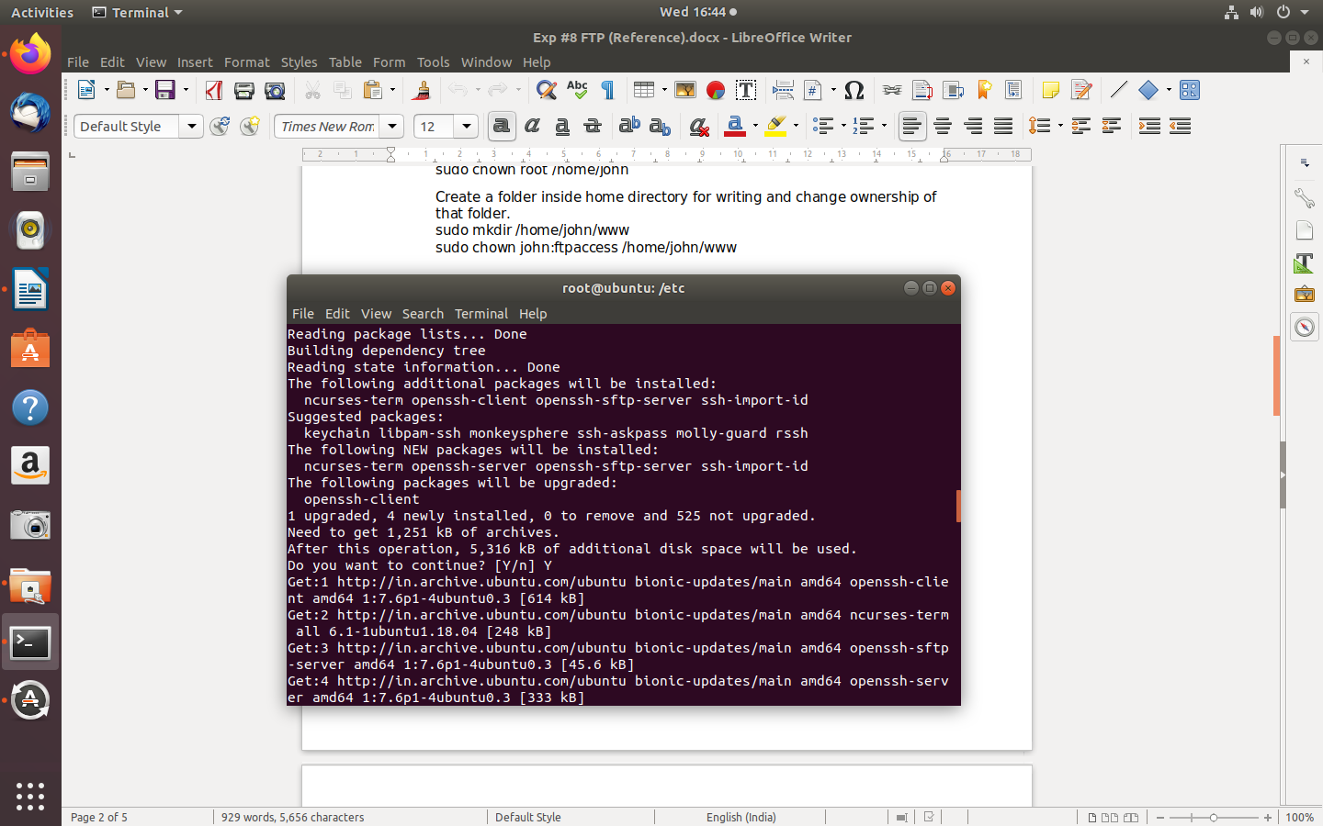

**Step 7 »** Create a new group **ftpaccess** for FTP users.

sudo groupadd ftpaccess

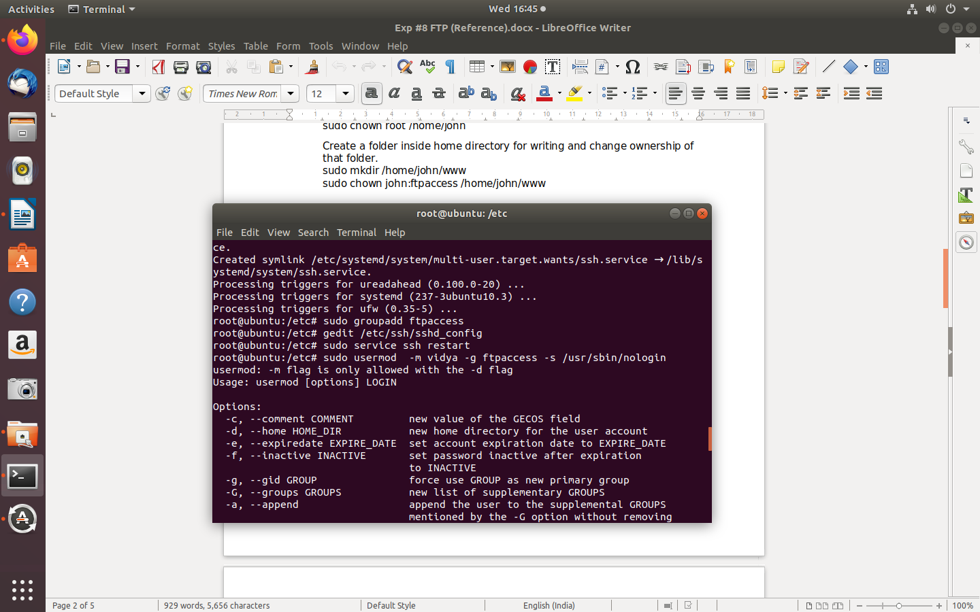

**Step 8 »** Now make changes in this **/etc/ssh/sshd_config** file.

» Find and comment the below line  
 Subsystem sftp /usr/lib/openssh/sftp-serverand

Add these lines at the end of the file.

Subsystem sftp internal-sftp  
Match group ftpaccess  
ChrootDirectory %h  
X11Forwarding no  
AllowTcpForwarding no  
ForceCommand internal-sftp



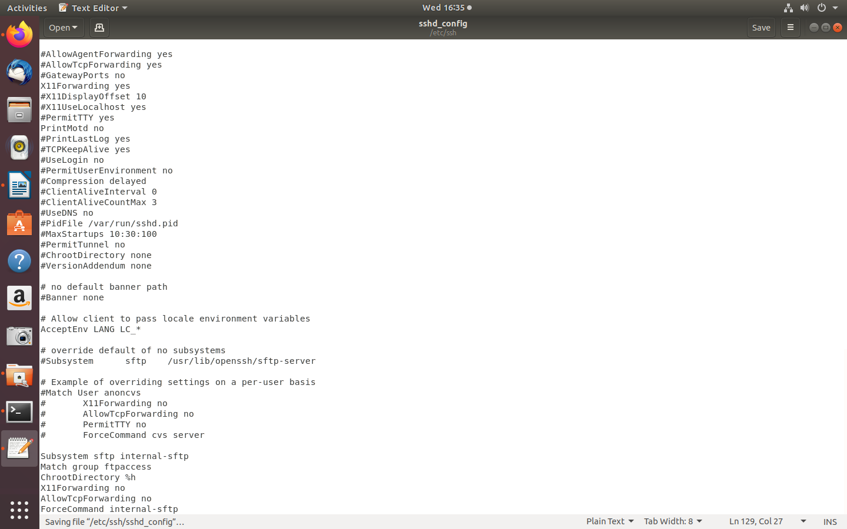

**Step 9 »** Restart sshd service.  
 sudo service ssh restart



**Step 10 »**  creating Users for sftp access.

Create user **sayali** with **ftpaccess** group and **/usr/bin/nologin** shell.  
sudo usermod -m sayali -g ftpaccess -s /usr/sbin/nologin  
sudo passwd sayali

Change ownership for the home directory.  
sudo chown root /home/sayali

Create a folder inside home directory for writing and change ownership of that folder.  
sudo mkdir /home/sayali/www  
sudo chown sayali:ftpaccess /home/sayali/www

**Testing FTP:**

To Test FTP server on Ubuntu 14.04(vsftpd ),need to run the following command:

1. **Internet File Transfer Program:**

It does connect to transfer files to and from a remote network ftp site. One must aware ftp username and password for user-based password authentication or with anonymous user access .

* 1. ftp ftp.example.com
  2. ftp 1.2.3.4
  3. ftp [user@ftp.example.com](mailto:user@ftp.example.com)
  4. ftp [ftp.freebsd.org](ftp://ftp.freebsd.org)

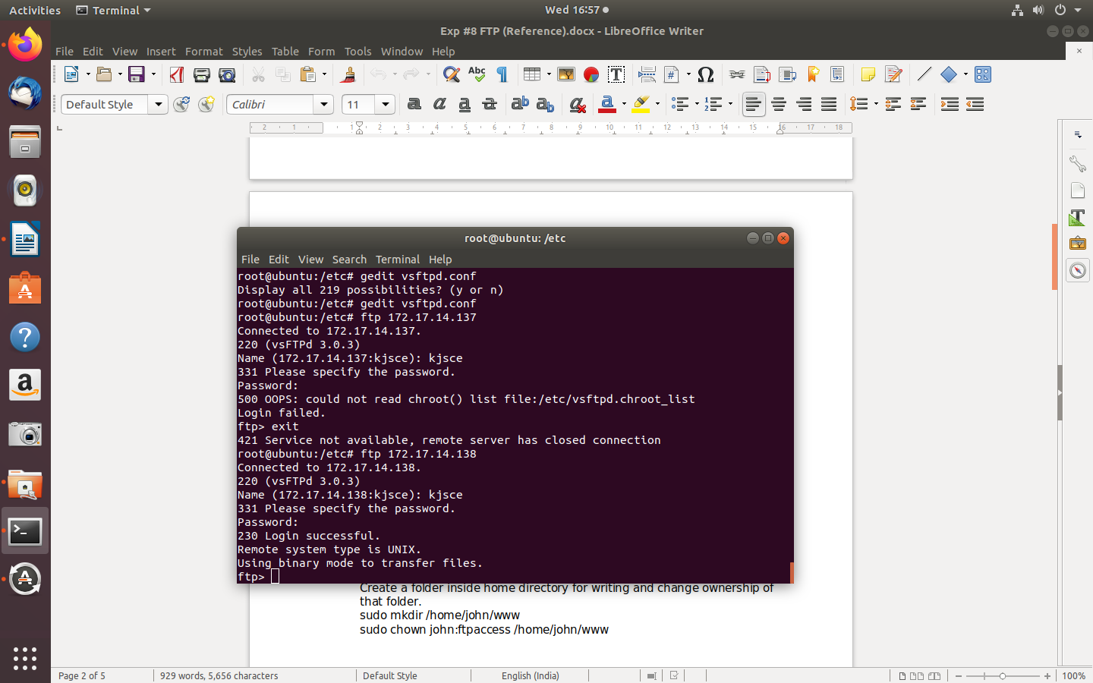

### List Current File:

### This command list the names of the files in the current remote directory

### ftp> ls

### C:\Users\Admin\Downloads\Exp 8\step 2 final.png

### Change Directory:

### To change directory on the remote machine use cd command:

### ftp> cd dirName

### Example : To change to pub directory, enter:

### ftp> cd pub

### Download / Copy file:

* 1. Download / Copy file o copy one file at a time from the remote ftp server to the local system use get command:
     1. get fileName
     2. get fileName newFileName
  2. In this example, download file resume.pdf in the current remote directory to (or on top of) a file with the same name, resume.pdf, in your current local directory:
     1. ftp> get resume.pdf

### Change Local Directory:

* + - * 1. To change directory on your local system:

ftp> lcd /path/to/new/dir

ftp> lcd /tmp

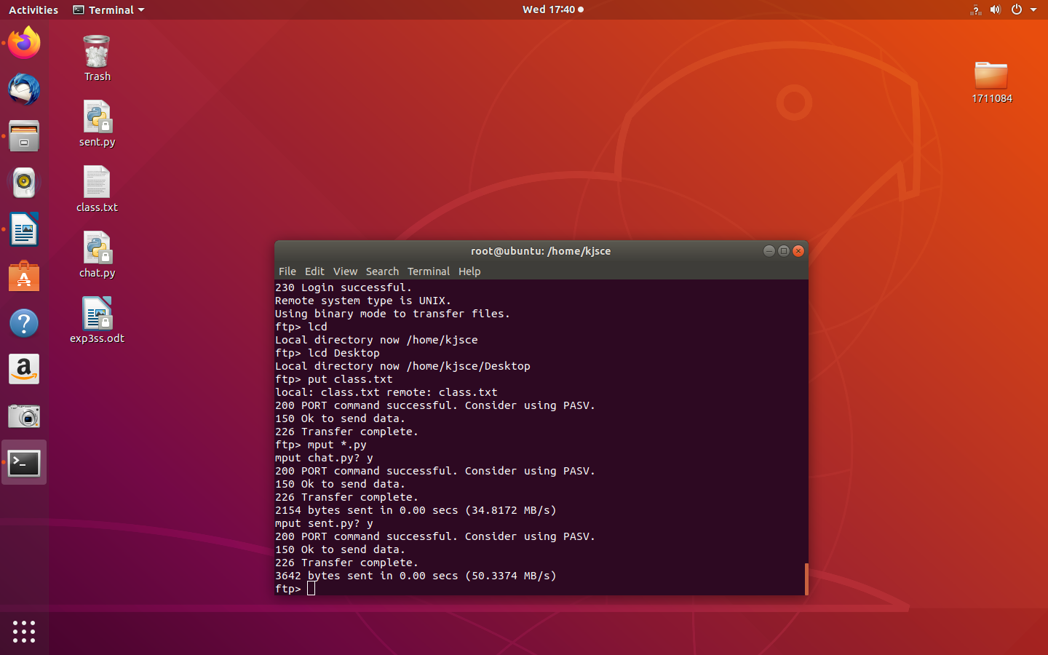

* + - * 1. Print local directory:

The lpwd command prints current download directory for local systems

ftp> lpwd

* + - * 1. pwd: To find out the pathname of the current directory on the remote ftp server, enter:

ftp> pwd

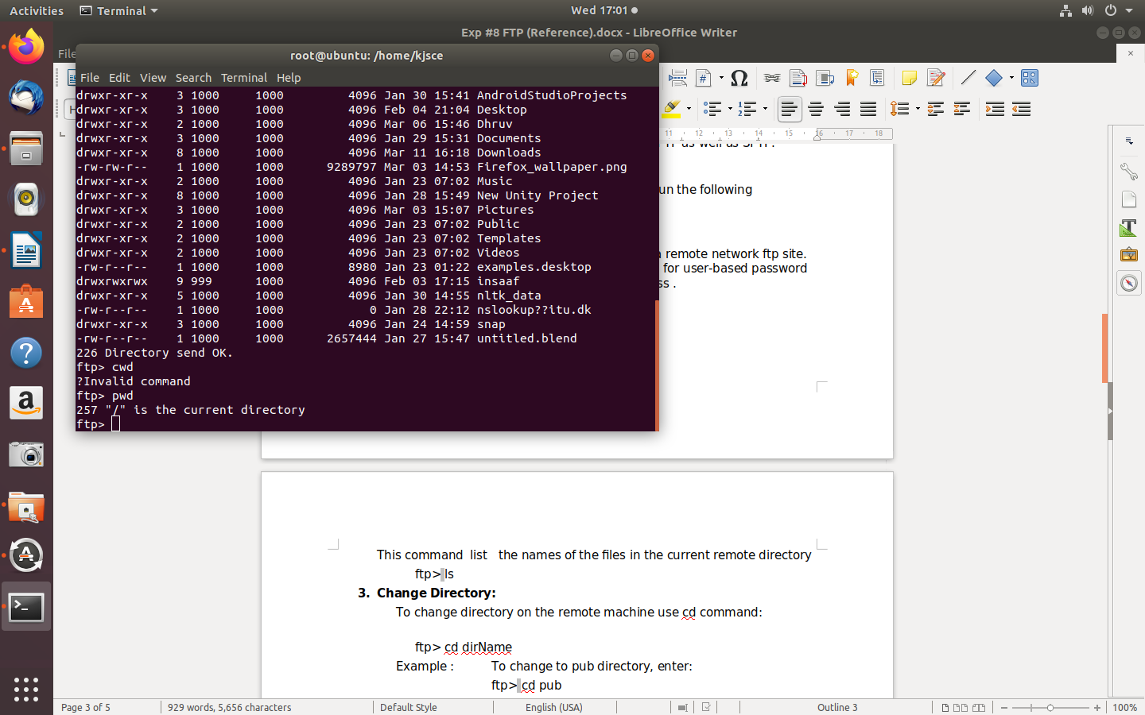

### Download Multiple Files:

* + 1. To copy multiple files from the remote ftp server to the local system.

ftp> mget *

* + 1. To download all perl files (ending with .pl extension)

ftp> mget *.pl

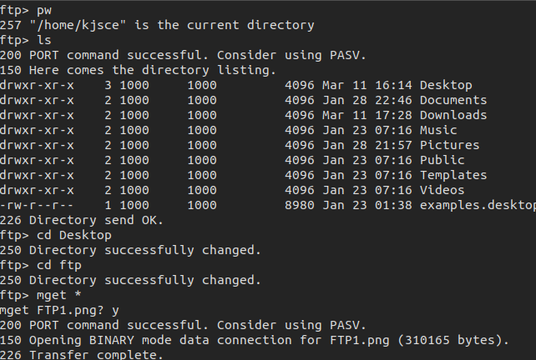

### Turn On / Off Interactive Prompting:

### The ftp command prompt sets interactive prompting; “on” which enables prompting so that you can verify of each step of the multiple commands, “off” allows the commands to act unimpeded. ftp> prompt on ftp> mput *.php ftp> prompt off  ftp> mget *.py

### C:\Users\Admin\Downloads\Exp 8\Screenshot from 2020-03-11 17-42-03.png

### Delete File:

### To delete a file in the current remote directory use delete command.

### ftp> delete fileName ftp> delete output.jpg

### C:\Users\Admin\Downloads\Exp 8\test11,3.png

### Upload One File:

### To copy one file at a time from the local systems to the remote ftp server.

### ftp> put filename

### Upload Image file

### ftp> put logo.jpg

### C:\Users\Admin\Downloads\Exp 8\test9,10.png

### Upload Multiple Files:

### To copy multiple files from the local system to the remote ftp server use mput command. Again, you may be prompted for a yes/no (y/n) answer before transferring each file.

### ftp> mput * ftp> mput *.pl

### Above example, upload all files from the current system.

### C:\Users\Admin\Downloads\Exp 8\test9,10.png

### Create a Directory:

### To make a new directory. ftp> mkdir dirName ftp> mkdir scripts ftp> cd scripts ftp> pwd

### Delete a Directory:

### Purpose is to remove or delete a directory.

### ftp> rmdir dirName ftp> rmdir images

### 

### Set The Mode Of File Transfer:

### The binary mode is recommended for almost all sort of files including images, zip files and much more. The binary mode provides less chance of a transmission error. The command are as follows:

### To set the mode of file transfer to ASCII ftp> ascii To set the mode of file transfer to binary. ftp> binary

### C:\Users\Admin\Downloads\Exp 8\Screenshot from 2020-03-11 17-44-25.png

### Connect To Another FTP Server:

### To open a connection with another ftp server.

### ftp> open [ftp.nixcraft.net.in](ftp://ftp.nixcraft.net.in)

### ftp> open 172.17.15.86

### C:\Users\Admin\Downloads\Exp 8\Screenshot from 2020-03-11 17-48-03.png

### Exit the FTP Session:

### Type quit or bye.

### ftp> quit OR ftp> bye

### C:\Users\Admin\Downloads\Exp 8\Screenshot from 2020-03-11 17-48-03.png

### Conclusion:

### The installation and configuration of FTP server was carried out successfully.